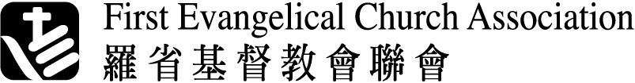

Tel: (626) 814-2773

1520 W. Cameron Ave., Suite 160, Mission E-mail: mission@feca.org
West Covina CA 91790, U.S.A. Website: www.feca.org

APPLICATION FOR MISSION FUNDING RECOMMENDATION FORM
Fillable Word document.

Instruction for the Applicant
Please fill in the information required in the top section of this form and forward to your recommender.
Applicant's Name: |  | Date:
In accordance with federal regulations, materials in an applicant's file, such as recommendation forms, are open to inspection upon request, unless the applicant has waived the right of access in advance. Please indicate your wish by completing and signing the statement below. Your right to review this form is considered waived if you do not check a response.
I (check one) DO DO NOT waive access to this recommendation.
Applicant: Once you fill out Recommender’s Information portion, please forward it to your recommender.

Recommender's information:
Name:
Position / title:
Organization:
Contact Phone #:
E-mail address:

Please answer the following questions based on your best knowledge of the applicant.
- How long have you known the applicant? Why would you recommend this applicant?

- How would you describe the applicant’s heart and calling in Missions?

- Please describe the applicant’s ministry work known to you.

- What do you think his/her most outstanding gifts?

- What areas of personal and ministry development might you recommend for the applicant?

- Please check as appropriate: I recommend this applicant strongly
I recommend this applicant
I recommend this applicant, but with reservation
I do not recommend this applicant
Recommender: Please email this recommendation form to FECA Association Missions Committee mission@feca.org

Date:
Thank you for taking the time to complete this recommendation form. We are deeply grateful for your help.

